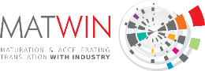
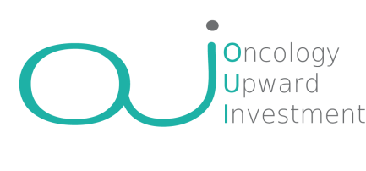
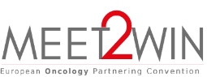

Application form

The OUI (Oncology Upward Investment) session is part of the MEET2WIN European Oncology Partnering Convention. Co-organized by MATWIN, and Angels Santé, OUI aims at showcasing innovative startups in oncology to a panel of European investors able to support their growth (from seed to serie A-B) including pre-seed & seed funds, VCs, foundations, etc. Selected projects will have the opportunity to:
      - benefit from a personalized coaching support to help them optimize their pitch
- pitch (10 minutes max) in front of a panel of investors and optimise their opportunity of collaboration and funding
When applying, you authorise MATWIN to share this form with investors for assessment and agree to associate and communicate on the facilitating role of MATWIN in the setting up of any successful fundraising post OUI exposure (e.g quote in a press release, interview, etc.).

Company Presentation (not confidential)

Identity | Logo of the company (in HD)
Name of the company:  Location:  Date of creation:  Manager (Name, First name):  Telephone:  e-mail: | [Insert here]
Activity summary (500 characters incl space)
Presentation of the company (1 500 characters incl space)
Management Team and Members of the Board (just list members)

Scientific information (not confidential)

Unmet Medical need & problems to be solved

Scientific Approach
(Expertise, Technologies, Highlights
and Ongoing Collaborations)
Innovation and Intellectual Property
(if none, why?)
Development Plan
(scientific, technological and clinical)

Financial information (not confidential)

Market & Competitive landscape
Development Plan & Business Model
(Financial, business and Human Ressources, Fundraising needs to do what?)

The whole file should not exceed 3 pages
Application to be send before Feb 28th 2023 at contact@matwin.fr

